Exercise1: Ranking and Window Functions

Goal: Use ROW_NUMBER(), RANK(), DENSE_RANK(), OVER(), and PARTITION BY.

Scenario:

Find the top 3 most expensive products in each category using different ranking functions.

Steps:

1. Use ROW_NUMBER() to assign a unique rank within each category.

2. Use RANK() and DENSE_RANK() to compare how ties are handled.

3. Use PARTITION BY Category and ORDER BY Price DESC.

CREATE TABLE dbo.products (

product_id INT PRIMARY KEY,

product_name VARCHAR(100) NOT NULL,

category VARCHAR(50) NOT NULL,

price DECIMAL(10, 2) NOT NULL,

stock_quantity INT

);

-- Insert sample data with some price ties within categories

INSERT INTO dbo.products (product_id, product_name, category, price, stock_quantity)

VALUES

(1, 'Ultra HD TV', 'Electronics', 1999.99, 15),

(2, 'Gaming Laptop', 'Electronics', 1899.99, 8),

(3, 'Premium Sound System', 'Electronics', 1999.99, 12),

(4, 'Wireless Earbuds', 'Electronics', 299.99, 30),

(5, 'Organic Cotton T-Shirt', 'Clothing', 49.99, 50),

(6, 'Designer Jeans', 'Clothing', 129.99, 25),

(7, 'Premium Leather Jacket', 'Clothing', 399.99, 10),

(8, 'Cashmere Sweater', 'Clothing', 199.99, 15),

(9, 'Luxury Mattress', 'Home', 2499.99, 5),

(10, 'Smart Thermostat', 'Home', 299.99, 20),

(11, 'Premium Blender', 'Home', 499.99, 12),

(12, 'Memory Foam Pillow', 'Home', 99.99, 40),

(13, 'Professional Camera', 'Electronics', 3499.99, 7),

(14, 'High-End DSLR Lens', 'Electronics', 1299.99, 4),

(15, 'Executive Office Chair', 'Furniture', 599.99, 9),

(16, 'Standing Desk', 'Furniture', 499.99, 6),

(17, 'Modern Sofa', 'Furniture', 1299.99, 3),

(18, 'Coffee Table', 'Furniture', 299.99, 12);

-- Query to compare all three ranking functions in one result

WITH ranked_products AS (

SELECT

category,

product_name,

price,

stock_quantity,

ROW_NUMBER() OVER (PARTITION BY category ORDER BY price DESC) AS row_num,

RANK() OVER (PARTITION BY category ORDER BY price DESC) AS rank_val,

DENSE_RANK() OVER (PARTITION BY category ORDER BY price DESC) AS dense_rank_val

FROM

dbo.products

)

SELECT

category,

product_name,

price,

stock_quantity,

row_num,

rank_val,

dense_rank_val

FROM

ranked_products

WHERE

row_num <= 3 -- For ROW_NUMBER(), ensures top 3 regardless of ties

OR rank_val <= 3 -- For RANK(), may include more than 3 if ties exist

OR dense_rank_val <= 3; -- For DENSE_RANK(), ensures top 3 ranking groups

-- Alternatively, show separate results for each ranking function

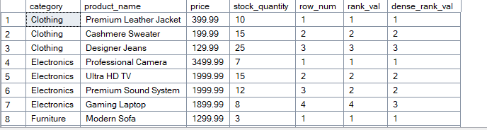

-- 1. Using ROW_NUMBER()

SELECT * FROM (

SELECT

category,

product_name,

price,

stock_quantity,

ROW_NUMBER() OVER (PARTITION BY category ORDER BY price DESC) AS rank

FROM

dbo.products

) AS rows

WHERE

rank <= 3;

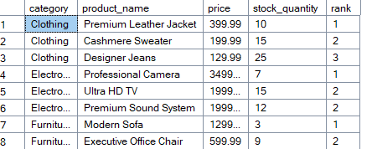

-- 2. Using RANK()

SELECT * FROM (

SELECT

category,

product_name,

price,

stock_quantity,

RANK() OVER (PARTITION BY category ORDER BY price DESC) AS rank

FROM

dbo.products

) AS ranks

WHERE

rank <= 3;

-- 3. Using DENSE_RANK()

SELECT * FROM (

SELECT

category,

product_name,

price,

stock_quantity,

DENSE_RANK() OVER (PARTITION BY category ORDER BY price DESC) AS rank

FROM

dbo.products

) AS dense_ranks

WHERE

rank <= 3;

-- Advanced example: Filter products with ranking and additional conditions

SELECT * FROM (

SELECT

category,

product_name,

price,

stock_quantity,

AVG(price) OVER (PARTITION BY category) AS avg_category_price,

RANK() OVER (PARTITION BY category ORDER BY price DESC) AS rank,

DENSE_RANK() OVER (ORDER BY price DESC) AS global_rank,

price - LAG(price, 1, 0) OVER (PARTITION BY category ORDER BY price DESC) AS price_diff_to_next

FROM

dbo.products

) AS advanced_analysis

WHERE

rank <= 3

AND stock_quantity > 5;

